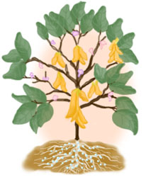
SOYBEANS

seeds candies
oil flour
margarine milk
paint crackers
glue roasted beans
ink soy sauce
animal food tofu
soap bread
fuel yeast
cosmetics noodles
cleaners cereal
shampoo pop
medicine coffee creamer
crayons mayonnaise

S | O | Y | S | A | U | C | E | S | E | I | D | N | A | C
A | H | M | B | L | G | S | C | E | F | K | S | C | K | O
O | Y | A | C | G | L | U | E | H | P | L | T | L | P | F
I | G | R | M | A | Y | O | N | N | A | I | S | E | O | F
L | D | G | E | P | D | R | U | P | I | M | A | A | P | E
D | L | A | D | S | O | A | P | E | N | J | E | N | J | E
F | E | R | I | B | F | O | N | L | T | L | Y | E | S | C
D | U | I | C | R | A | Y | O | N | S | F | Q | R | C | R
E | F | N | I | E | M | H | O | F | E | L | G | S | I | E
H | J | E | N | A | P | K | D | L | E | O | S | T | T | A
K | N | I | E | D | M | H | L | M | D | U | C | D | E | M
H | L | O | L | A | E | R | E | C | S | R | E | V | M | E
C | R | A | C | K | E | R | S | U | F | O | T | W | S | R
G | P | F | S | N | A | E | B | D | E | T | S | A | O | R
D | M | J | D | O | O | F | L | A | M | I | N | A | C | Y

