Harvest Days: Learning with seeds

Experimenting with Seeds
Some large seeds reveal secrets you can't see in smaller ones. Beans, for example, are great for showing students how seeds are tiny embryos ready to burst out and grow.
Simply, have The Students:
- Place 15 soybeans or corn or wheat on a sheet of paper.
- Measure the length of the row. Each seed should touch the ones next to it.
- Trace a line marking the beginning and ending of the seeds; then remove the beans and soak them in a jar of water overnight.
- Next day, have the students observe and compare the soaked seeds to the non soaked seeds.
- Describe the shape and size.
- Arrange the soaked seeds in the same way, along the line drawn yesterday.
- Measure the length of the seeds again. Has anything changed? Why?
- How long is the line now?
- The water will have caused them to expand and has started the seed to germinate.
- Ask the students to list the conditions of growth:
- Light, Water, Temperature, Room to Grow, Air, Time, Nutrients.
- If the seed does not have all the conditions for good growth it will eventually wither and die.

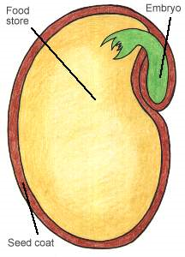
Examine the seeds
- Carefully peel off one bean's outer coating and separate the halves,
- called cotyledons, which feed the plant until its roots, stems and leaves grow to find nutrients in the soil, air and water.
- Using a magnifying glass, examine the curled embryo at the top of one cotyledon.
- How many cotyledons are there? Do you see a miniature plant (leaves and root tip)?
Make a Seed Viewer
Another fun experiment is to make a simple seed viewer to watch a few seeds germinate.
- Line the inside of a recycled clear plastic water bottle (cut in half) with dark construction paper.
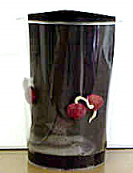
- Fill the centre with crumpled paper towels.
- Carefully slip 4 different seeds from each Harvest Days Stop (corn, wheat, soybeans) between the construction paper and glass. Place the same kind of seeds together, separating each variety around the perimeter of the bottle.
- Pour water into the centre of the bottle until the paper towels are saturated.
- To create darkness, loosely wrap another piece of construction paper around the outside of the glass.
- Place in a warm spot; keep the paper towels moist.
- Carefully lift the outside paper every day to see what's happening. In a few days you'll see the seed coats crack and roots emerge.
- Which seeds sprouted the fastest, which the slowest?
- Once the leaves sprout, plant two of the seedlings in a pot filled with potting soil and water.
- Leave the other two between the paper and the glass and compare how soil and light affect growth in contrast to dark and soilless conditions.
- Have the class keep a journal with pictures documenting each day of its growth.

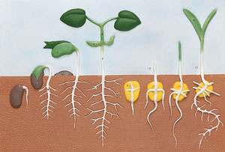Sample observation questions:
1. Which plant spouted first? Was it the same for every bottle?
2. Which plant looks like grass?
3. Which plant has the most leaves after 20 days?
4. Do all the plants look the same? Why not?
5. Describe the differences among the plant shapes

